# Target Metrics

Overall - Accuracy: 0.7400, Precision: 0.7499, Recall: 0.7400, F1: 0.7299

Class-specific metrics:

Carbon neutral(ity) - Precision: 0.7083, Recall: 0.6800, F1: 0.6939

Emissions reduction target - Precision: 0.8000, Recall: 0.4800, F1: 0.6000

Net zero - Precision: 0.6765, Recall: 0.9200, F1: 0.7797

No target - Precision: 0.8148, Recall: 0.8800, F1: 0.8462

# Year Metrics

Overall - Accuracy: 0.7900, Precision: 0.7911, Recall: 0.7900, F1: 0.7881

Class-specific metrics:

2020 - Precision: 0.0000, Recall: 0.0000, F1: 0.0000

2022 - Precision: 0.0000, Recall: 0.0000, F1: 0.0000

2025 - Precision: 0.6000, Recall: 0.6000, F1: 0.6000

2030 - Precision: 0.7826, Recall: 0.7200, F1: 0.7500

2031-32 - Precision: 0.0000, Recall: 0.0000, F1: 0.0000

2032 - Precision: 0.0000, Recall: 0.0000, F1: 0.0000

2035 - Precision: 0.8000, Recall: 0.8000, F1: 0.8000

2040 - Precision: 0.9091, Recall: 1.0000, F1: 0.9524

2050 - Precision: 0.8750, Recall: 0.7778, F1: 0.8235

2060 - Precision: 0.0000, Recall: 0.0000, F1: 0.0000

NZ E (Net Zero Emissions) is Indonesia's commitment, but Bank Mandiri specifically mentions aligning with this goal, so I will use 2050 as a target year for Bank Mandiri's net-zero commitment, which is in line with the government's timeline - Precision: 0.0000, Recall: 0.0000, F1: 0.0000

No target - Precision: 0.7931, Recall: 0.9200, F1: 0.8519

# Other Metrics

Quote Accuracy: 0.4000

Overall Accuracy: 0.6900

Valid XML Percentage: 1.0000

# Confusion Matrices

Target Confusion Matrix:

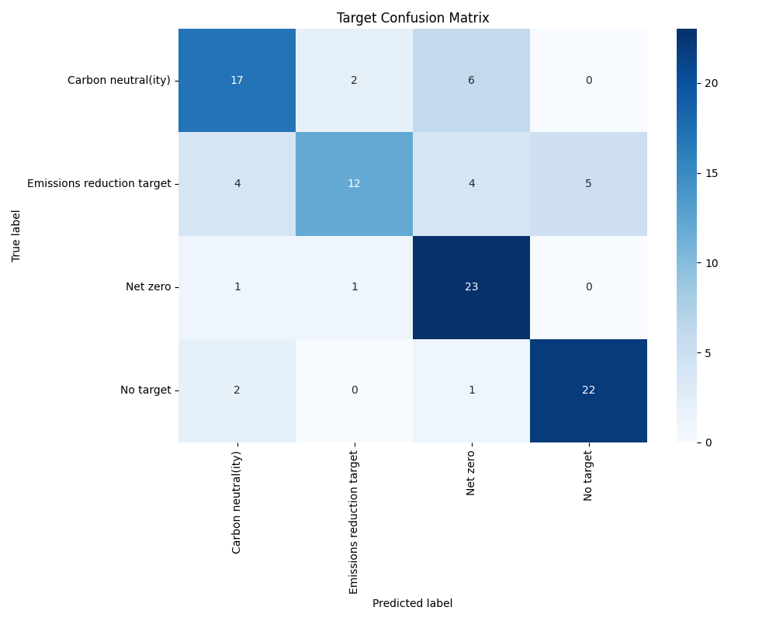

Year Confusion Matrix:

